Title
Forename Surname ^{1,*}, Forename Surname ² and Forename Surname ²
¹ IAMU member university, Country
² Second affiliation, Country
* Corresponding author: author@university.xx; Tel.: +00-00-000-0000.

Keywords: first keyword; second keyword; third keyword (three to five pertinent keywords should be listed)

These instructions provide authors with guidelines for typing camera-ready abstracts for the 24rd International Association of Maritime Universities Conference Book. This electronic document is a “live” template and is used to format the abstract and style the text. Abstracts are limited to one page of text (and a second page may only be provided for relevant tables/figures). The abstract should clearly explain the content and relevance of the work. Authors must keep their camera-ready abstracts in the A4 paper size, Times New Roman font is strictly required, all margins, line spaces and text fonts are prescribed, and page numbers should not be added. Reference list style has to be the same as for the WMU Journal of Maritime Affairs (JoMA 2020). References have to be cited in the text by name and year in parentheses.
The theme of the IAMUC is “Protecting Our Mariners – Promoting Our Industry – Providing for the Future.” When submitting your abstract, please indicate one of the following theme categories in which the abstract will be registered and reviewed:
- Policy/Political/Legal aspect,
- Economic/Trade aspect,
- Social/Maritime Education & Training aspect,
- Technological aspect,
- Environmental aspect.

The abstract submission deadline is 4th of February 2024. Authors should upload their abstracts to the manuscript system, which will open in early January 2024.
Submission of an abstract will be taken to imply that it represents an original work and that it has not been previously published or considered elsewhere for publication. Please be aware that authors are responsible for the English language quality of the text. Notification of acceptance will be given by 4th of March 2024.
The accepted abstract will be assigned by the International Program Committee for oral or poster presentation, not only on the basis of the author's preference indicated in the email submission, but also on the quality of the abstract and number of the oral presentations allocated.
All presented abstracts will be published in the Conference Book with assigned ISSN identifier. The authors will be invited to submit a full paper version for inclusion in the IAMU Conference Proceedings. Instructions to prepare the full paper will be emailed together with the notification of the abstract. The full paper will be requested by 3rd of May 2024. The Proceedings papers authors will have opportunity to submit an extended version of the paper to IAMUC Special Issue of the IAMU Section of WMU Journal of Maritime Affairs.

References
International Hydrographic Organization (2017) Information on IHO standards related to ENC and ECDIS. Version 1.1. IHO, Monaco
WMU Journal of Maritime Affairs (JoMA) (2020) WMU Journal of Maritime Affairs, Submission guidelines. Springer Nature. https://www.springer.com/journal/13437/submission-guidelines. Accessed 3 March 2020
Svilicic B, Rudan I, Jugović A, Zec D (2019) Cyber security testing of shipboard chart radar. Proceedings of the International Association of Maritime Universities Conference, Tokyo, Japan, 129-134
Walling SA, Hill JC (2014) Elementary Marine Navigation. Cambridge University Press, Cambridge

Illustrations should contain only English labels and be prepared in the final published size, not oversized or undersized. Each illustration has to have a caption (Figure 1).
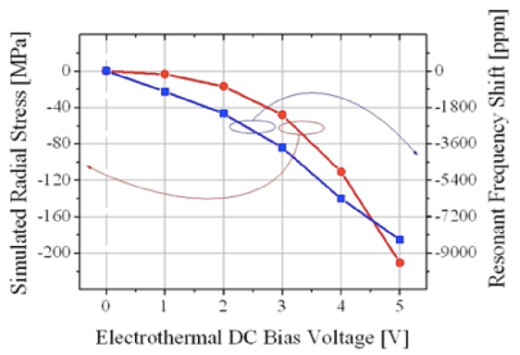
Figure 1. An example of a figure.

Tables have to be submitted as editable text and not as images. Each table has to have a caption (Table 1).
Table 1. An example of a table.
An example of a column heading | Column A | Column B
First entry | 1 | 2
Second entry | 3 | 4
Third entry | 5 | 6

Acknowledgements
If a funding has been provided for the research, please include brief information on the program or type of grants and awards.

