Title
Forename Surname ^{1,*}, Forename Surname ² and Forename Surname ²
¹ IAMU member university, Country
² Second affiliation, Country
* Corresponding author: author@university.xx; Tel.: +00-00-000-0000.

Abstract: Authors must prepare their papers by strictly adhering to this template. Figures and tables have to be embedded in the text and not supplied separately. The length of the paper is limited to 6 pages and the file size should not exceed 10 MB. Papers will be peer-reviewed and have to meet IAMU standards for both technical content and written English. Authors must submit their papers electronically to bghosh@maritime.edu.
Keywords: first keyword; second keyword; third keyword (three to five pertinent keywords should be listed)

1. Introduction
The template, saved as “MS Word Document”, provides authors with most of the formatting specifications needed for preparing electronic versions of their papers. The various components of the paper (title, abstract, keywords, text, heads, etc.) are already defined on the style sheet with the appropriate name supplied, e.g. choose "IAMUS Heading 1" for the first order heading text, "IAMUS Text" for the text etc. Authors must keep their camera-ready paper in the A4 paper size, Times New Roman font is strictly required, all margins, line spaces and text fonts are prescribed, and page numbers should not be added.
2. Submission
Submission should contain the paper and cover letter in MS Word document files. Authors are fully responsible for the content/originality of the paper and for the English language quality of the text. Therefore, it is necessary for the complete text of papers to be thoroughly checked or proof-read by an English language expert.
Authors have to submit their papers electronically to bghosh@maritime.edu. All correspondence, including notification on the submission decision and request for revision, will be sent by the e-mail.

2.1 Quality of Papers
Only papers that present original, unpublished research material and are not being submitted for publication elsewhere will be consider for publications in the Proceedings. Papers will be peer-reviewed to ensure both accuracy and relevance.
3. Paper Text Formatting
Papers have to be written in good English using either UK or US spelling. The minimum length of the paper should be about 4 pages and maximum length should not exceed 6 pages including illustrations, tables and references. The file size should not exceed 10 MB.

3.1. Illustrations
Illustrations should contain only English labels and be prepared in the final published size, not oversized or undersized. Illustrations have to be embedded into the text (not supplied separately) and placed next to the relevant text in the paper. Each illustration has to have a caption (Figure 1).
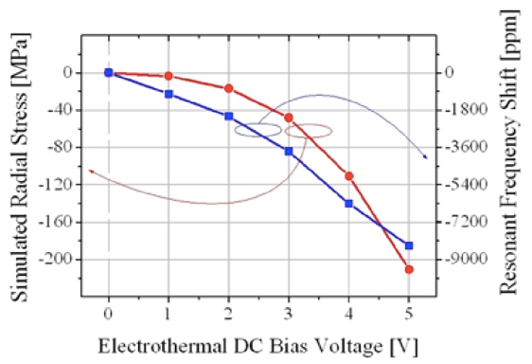

Figure 1. An example of a figure.

3.2. Tables
Tables have to be submitted as editable text and not as images. Tables have to be embedded into the text (not supplied separately) and placed next to the relevant text in the paper. Tables have to be numbered consecutively in accordance with their appearance in the text. Each table should have a caption (Table 1).

Table 1. An example of a table.
An example of a column heading | Column A | Column B
First entry | 1 | 2
Second entry | 3 | 4
Third entry | 5 | 6
3.3. Mathematical Formulae
Formulae and equations have to be in editable format. Any equations that have to be displayed separately from the text should be numbered consecutively with Arabic numerals in parentheses on the right hand side of the page (if referred to explicitly in the text). This is an example of an equation:
y = 2020, | (1)
the text following an equation has to be a new paragraph. Equations have to be punctuate as regular text.

3.4. Footnotes and Acronyms
Footnotes should be avoided. Acronyms have to be spelled out on their first use, followed by the acronym in parentheses.

3.5. References
Reference list style has to be the same as for the WMU Journal of Maritime Affairs (JoMA 2020). References have to be cited in the text by name and year in parentheses. All references mentioned in the Reference list have to be cited in the text, and vice versa. Reference list entries have to be alphabetized by the last names of the first author of each work. Order multi-author publications of the same first author alphabetically with respect to second, third, etc. author. Publications of exactly the same author(s) have to be ordered chronologically. Some examples of references are given at the end of this template in the References section, which will allow authors to assemble their reference list according to the correct format and font size.

Acknowledgements
If a funding has been provided for the research, please include brief information on the program or type of grants and awards.

References
International Hydrographic Organization (2017) Information on IHO standards related to ENC and ECDIS. Version 1.1. IHO, Monaco
Jeevan J, Ramamoorthy K, Salleh NHM et al (2020) Implication of e-navigation on maritime transportation efficiency. WMU J Marit Affairs. https://doi.org/10.1007/s13437-020-00194-z
Kitada M, Bhirugnath-Bhookhun M (2019) Beyond business as usual: the role of women professionals in maritime clusters. WMU J Marit Affairs 18:639–653. https://doi.org/10.1007/s13437-019-00178-8
WMU Journal of Maritime Affairs (JoMA) (2020) WMU Journal of Maritime Affairs, Submission guidelines. Springer Nature. https://www.springer.com/journal/13437/submission-guidelines. Accessed 3 March 2020
Svilicic B, Rudan I, Jugović A, Zec D (2019) Cyber security testing of shipboard chart radar. Proceedings of the International Association of Maritime Universities Conference, Tokyo, Japan, 129-134
Walling SA, Hill JC (2014) Elementary Marine Navigation. Cambridge University Press, Cambridge

